**Jeevan ID**

**A Temporary, Ethical Emergency Identity System for Disaster Relief**

**1. Problem Statement**

During natural disasters such as floods, cyclones, earthquakes, and landslides, millions of people lose personal identity documents and get separated from their families. According to global disaster statistics, over 200 million people are affected by disasters every year, and nearly 75% of Indian districts are disaster-prone.

Without reliable identification, victims often face delays in food distribution, medical treatment, and shelter access. Existing identity systems are permanent, centralized, and heavily dependent on internet connectivity, making them unsuitable during disaster emergencies.

**2. Proposed Solution – Jeevan ID**

Jeevan ID is a temporary, offline-capable emergency identity system designed exclusively for disaster response and recovery. It provides affected individuals with a QR-based digital identity using minimal, non-biometric information such as an alias, approximate age, health condition, and optional symbolic or voice identifiers.The identity exists only during the disaster relief phase and automatically expires after recovery, ensuring ethical use and privacy protection.

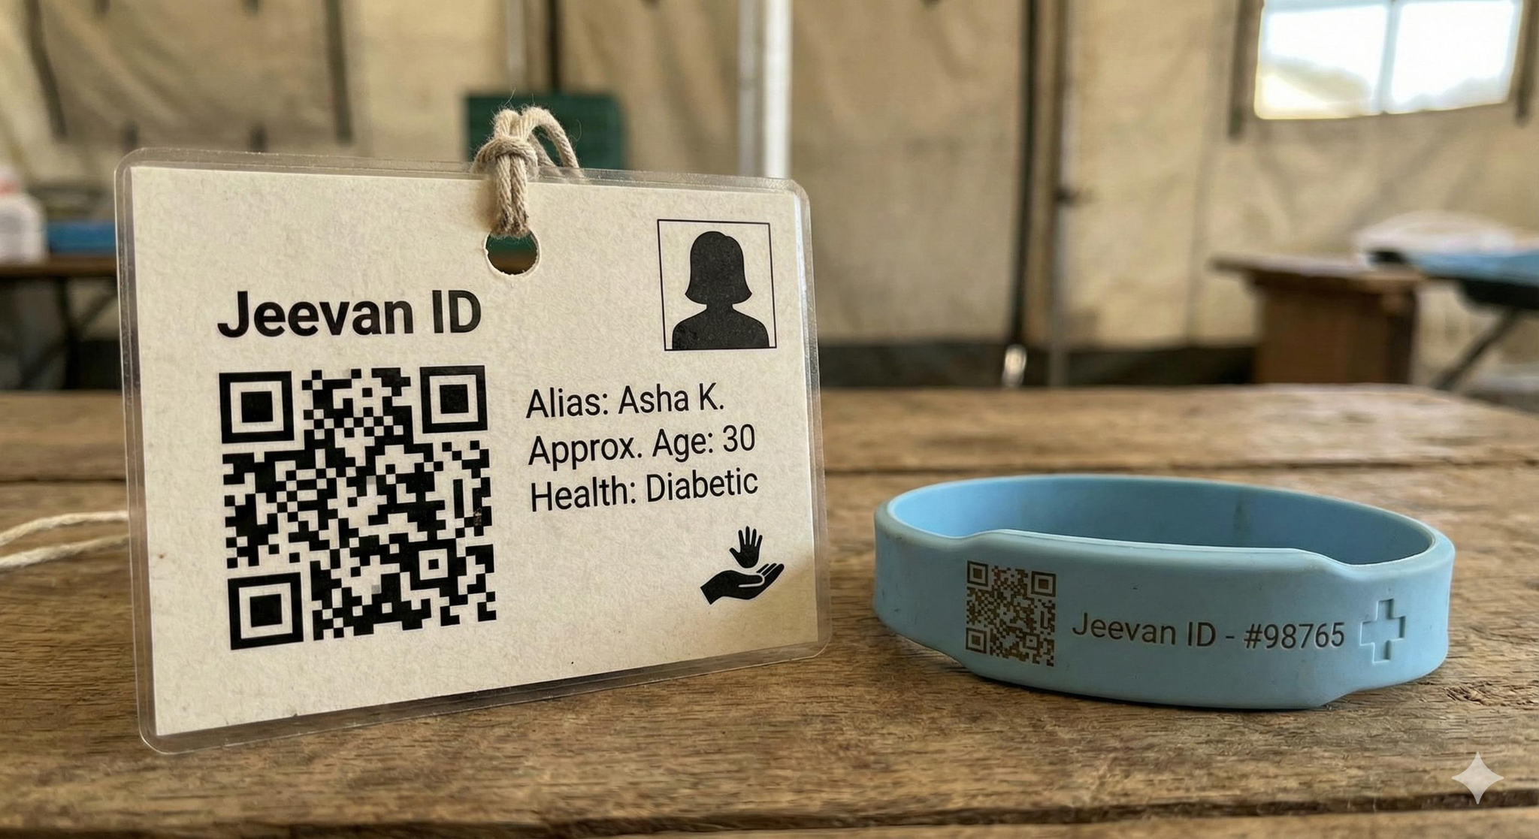

**3. Key Features**

* Temporary and time-bound identity
* Offline-first operation
* QR-based ID card or wristband
* Privacy-first and consent-driven design
* No permanent biometric or national ID linkage
* Automatic data deletion after relief phase

**4. System Workflow**

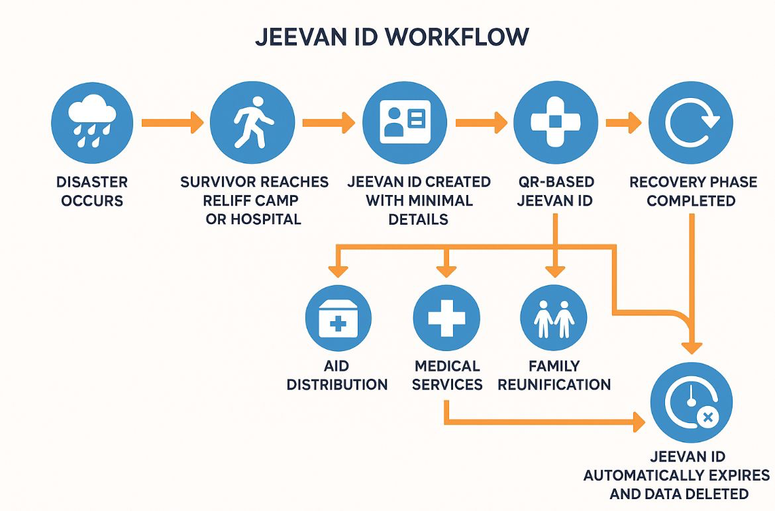

**5. Offline Synchronization & Security**

Jeevan ID operates using decentralized local devices at relief camps and hospitals. Data is stored securely on local nodes and synchronized only when connectivity becomes available using encrypted channels. There is no permanent central database, reducing misuse and surveillance risks.

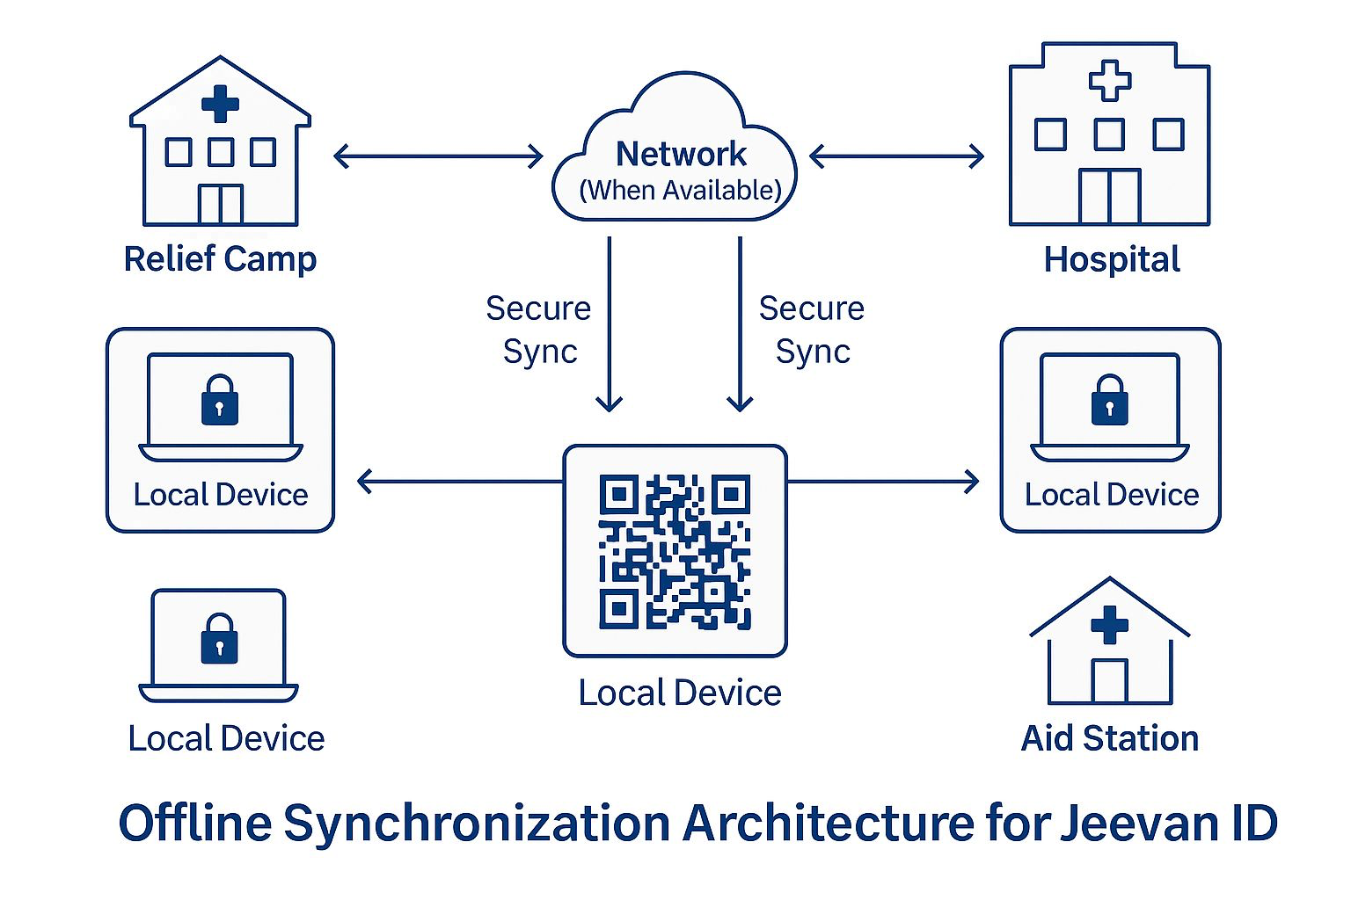

**6. Social & Humanitarian Impact**

• Fair and timely aid distribution  
• Faster family reunification  
• Medical continuity across locations  
• Reduced duplication and exclusion  
• Preserves dignity and privacy

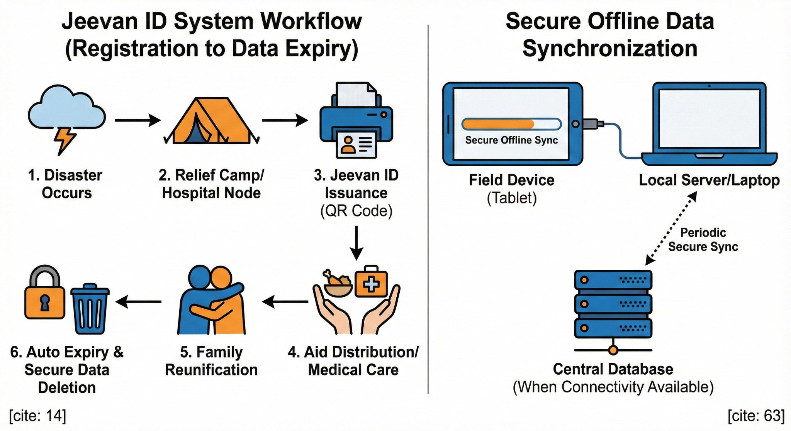

**7. Scalability and Future Scope**

Jeevan ID is designed to scale across different disaster types and regions using existing devices such as tablets and laptops used by relief teams. Its offline-first and minimal-data approach makes it suitable for remote and resource-limited areas. In the future, Jeevan ID can be extended with multilingual support and accessibility features, and with consent-based integration of emergency health information. With institutional adoption, Jeevan ID can evolve into a standard ethical emergency identity framework for disaster management.

**8. Conclusion**

Jeevan ID introduces a new paradigm for ethical identity management during disasters. By focusing on temporariness, privacy, and offline operation, it strengthens coordination, trust, and effectiveness in disaster relief and management across India and other disaster-prone regions.